TASK -12

Q1.

\*Table created : Employedetails

* Values Inserted Successfully

1. Ename and sal of employees whose salary are greater than or equal to 2200?

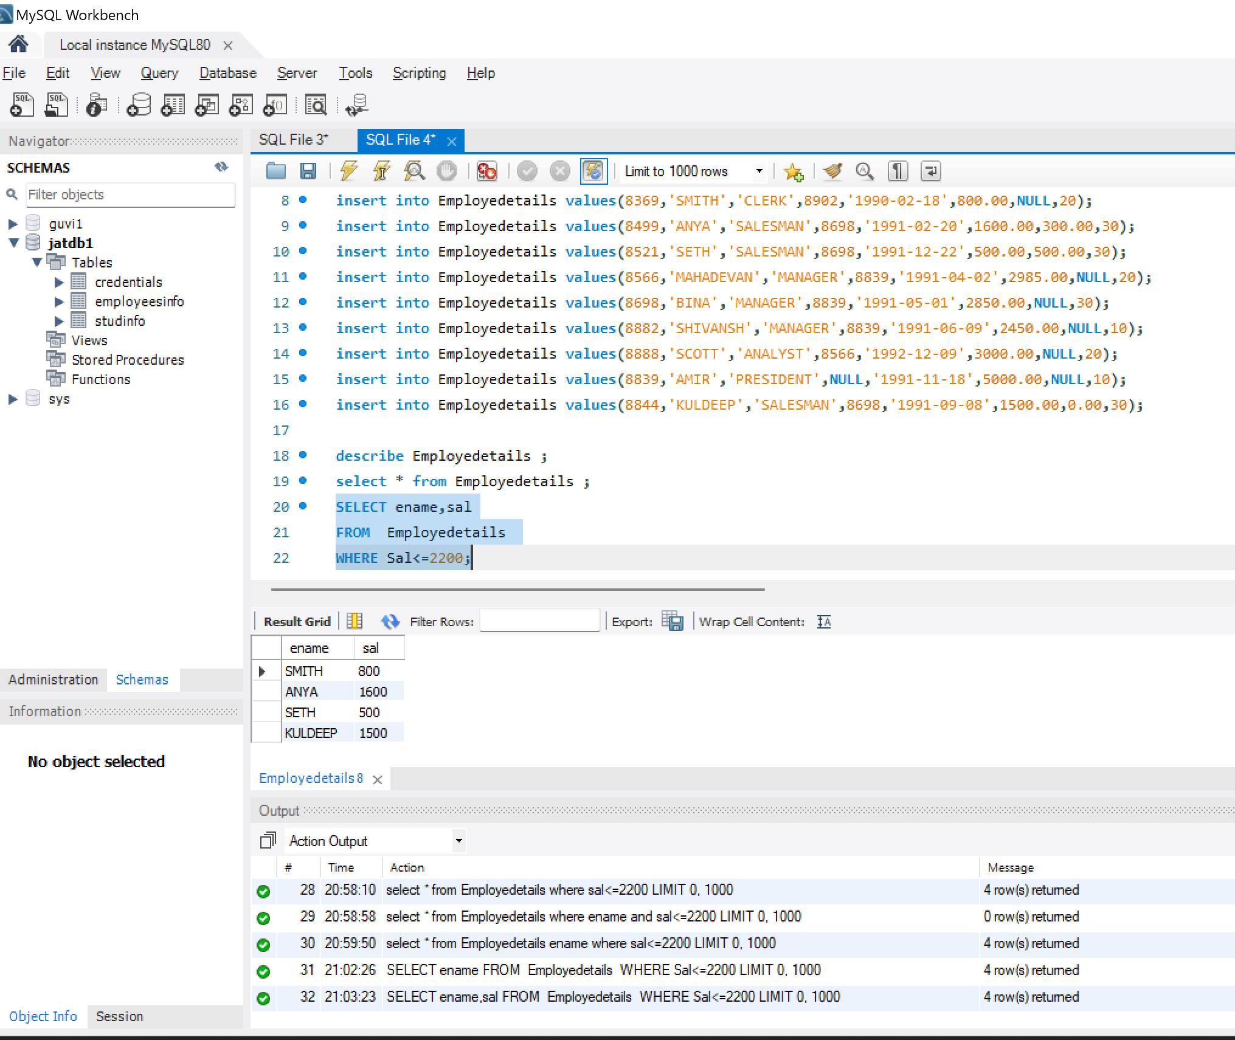

1. Display details of employees who are not getting commission ?

1. display employee name and salary of those employees who don’t have their salary in the range of 2500 to 4000?

D.Display the name,job title and salary of employees who don’t have a manager?

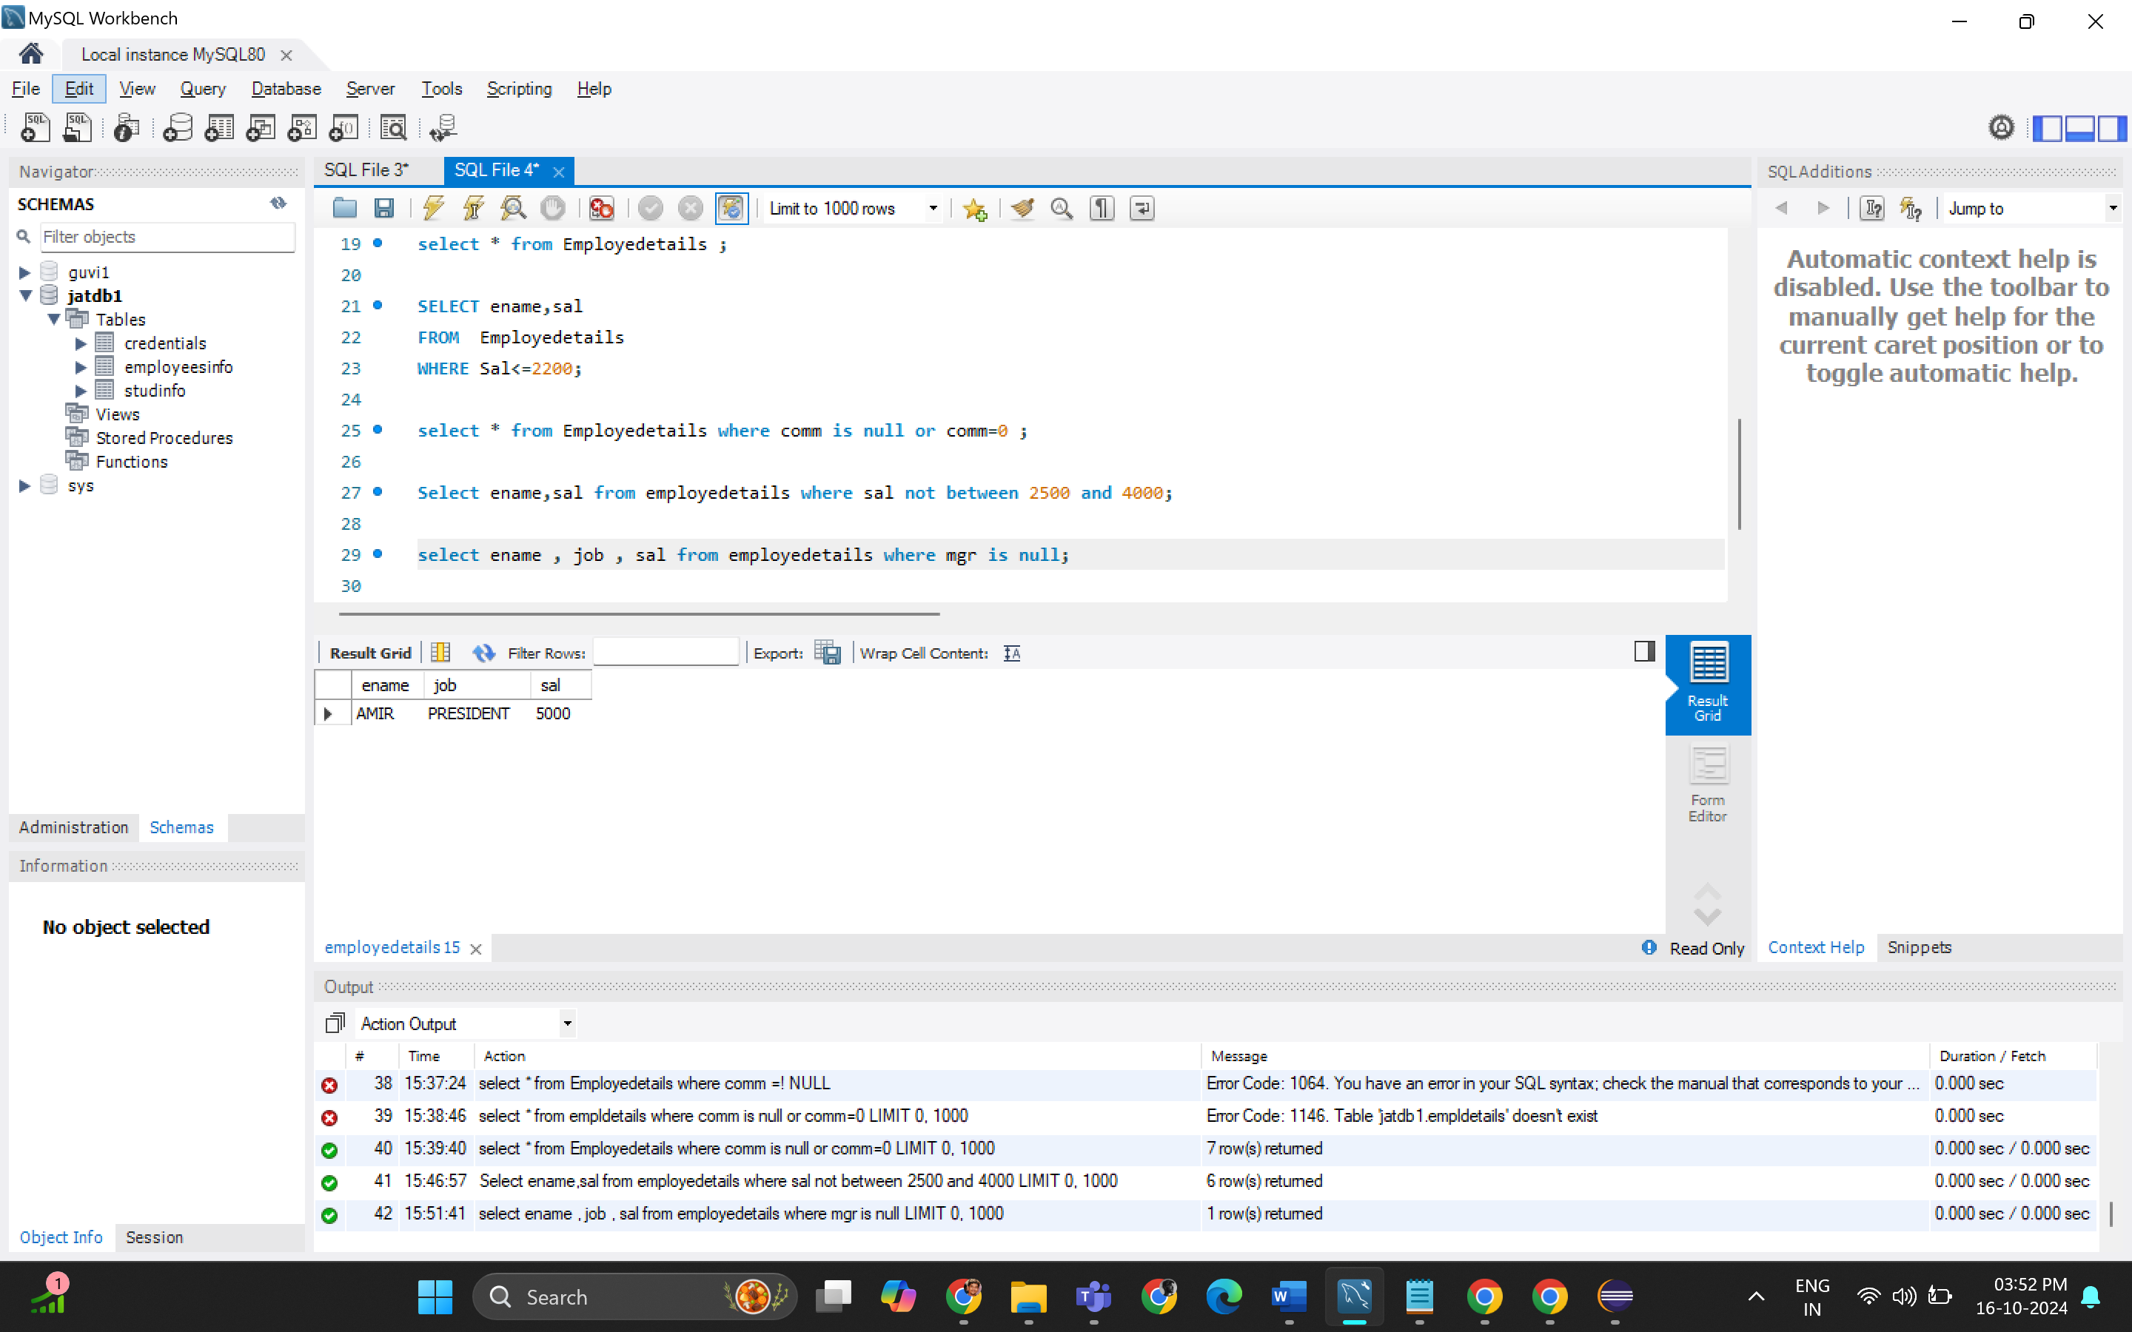

1. display the name of an employee whose name contains “A” as third alphabet?

There are no employees .So Output will be empty.

F. displays the name of an employee whose name contains “T” as the last alphabet ?

Q2.

\*First create a table in SQL workbench

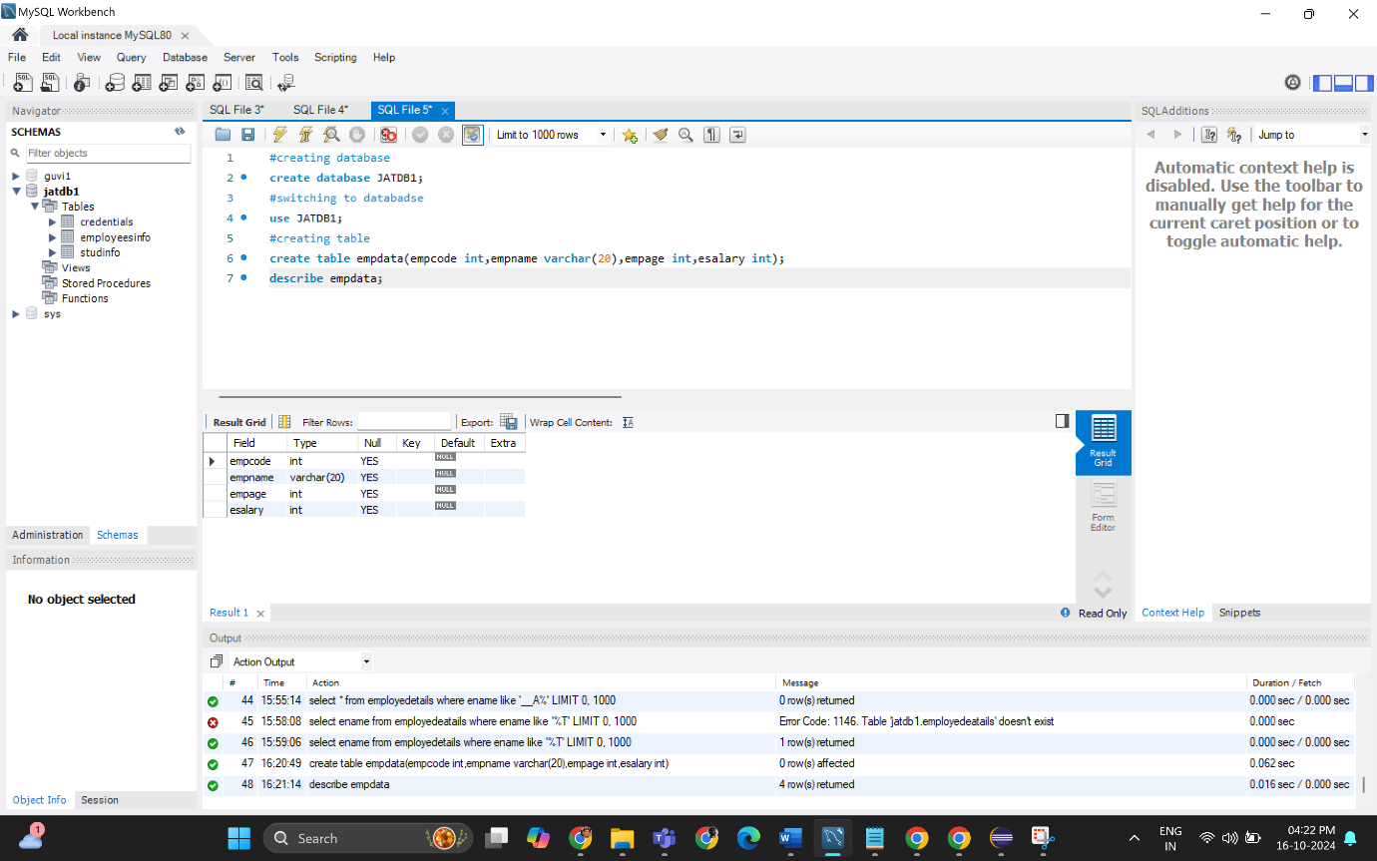

\*Insert the data in the table using JDBC

\*Check values are inserted

Values added Successfully

